Masculine Rhyme Couplets

🎯 What is Masculine Rhyme Couplets
# Source: AI Source: Provided by: [Data Path: Persons Table -> ID Column: 1, Name_En Column: Motasem Essam] -> From: [Chatgpt (GPT-4-turbo)] on [8/2/2025]
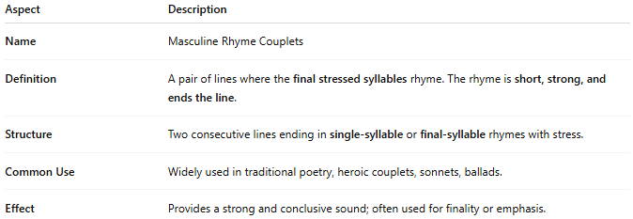
Aspect | Description
Name | Masculine Rhyme Couplets
Definition | A pair of lines where the final stressed syllables rhyme. The rhyme is short, strong, and ends the line.
Structure | Two consecutive lines ending in single-syllable or final-syllable rhymes with stress.
Common Use | Widely used in traditional poetry, heroic couplets, sonnets, ballads.
Effect | Provides a strong and conclusive sound; often used for finality or emphasis.

✅ Example of Masculine Rhyme in a Couplet
# Source: AI Source: Provided by: [Data Path: Persons Table -> ID Column: 1, Name_En Column: Motasem Essam] -> From: [Chatgpt (GPT-4-turbo)] on [8/2/2025]
He drew his sword and took his stand
Prepared to fight and guard his land
- "stand" / "land" rhyme in their final stressed syllable, forming a masculine rhyme.

🧠 Note:
# Source: AI Source: Provided by: [Data Path: Persons Table -> ID Column: 1, Name_En Column: Motasem Essam] -> From: [Chatgpt (GPT-4-turbo)] on [8/2/2025]
- Masculine rhymes are the most common rhyme type in English.
- They contrast with feminine rhymes, which include an unstressed syllable after the main stressed one.

